Chris Carrier WD 220

10/16/13 Chapter 5

5-1

<!DOCTYPE html PUBLIC "-//W3C//DTD XHTML 1.0 Strict//EN"

"http://www.w3.org/TR/xhtml1/DTD/xhtml1-strict.dtd">

<html xmlns="http://www.w3.org/1999/xhtml">

<head>

<title>Hit Counter</title>

<meta http-equiv="content-type" content="text/html; charset=iso-8859-1" />

</head>

<body>

<?php

$CounterFile = "hitcount.txt";

if(file_exists($CounterFile)){

$Hits = file_get_contents($CounterFile);

++$Hits;

}

else{

$Hits = 1;

}

echo "<h1>There have been $Hits hits to this page.</h1>\n";

if(file_put_contents($CounterFile, $Hits))

echo "<p>The counter file has been updated.</p>\n";

?>

</body>

</html>

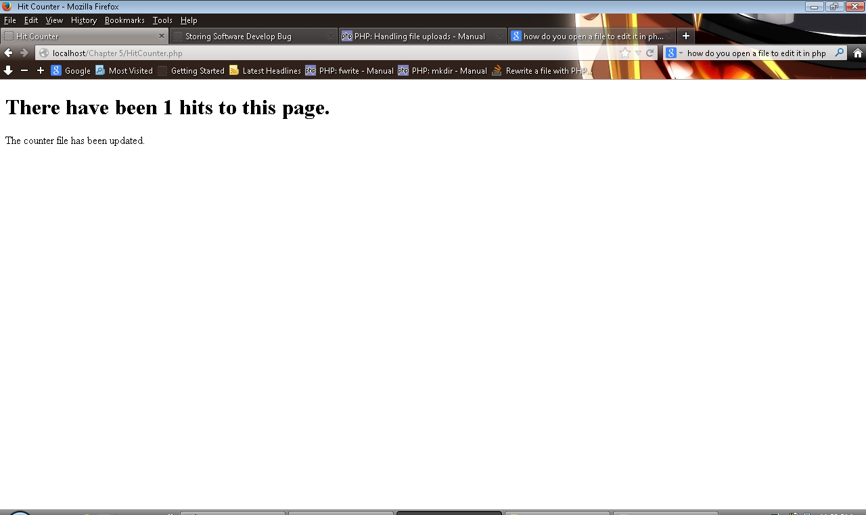

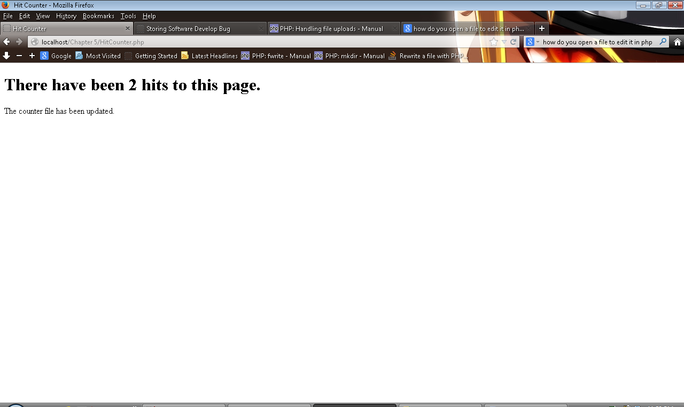

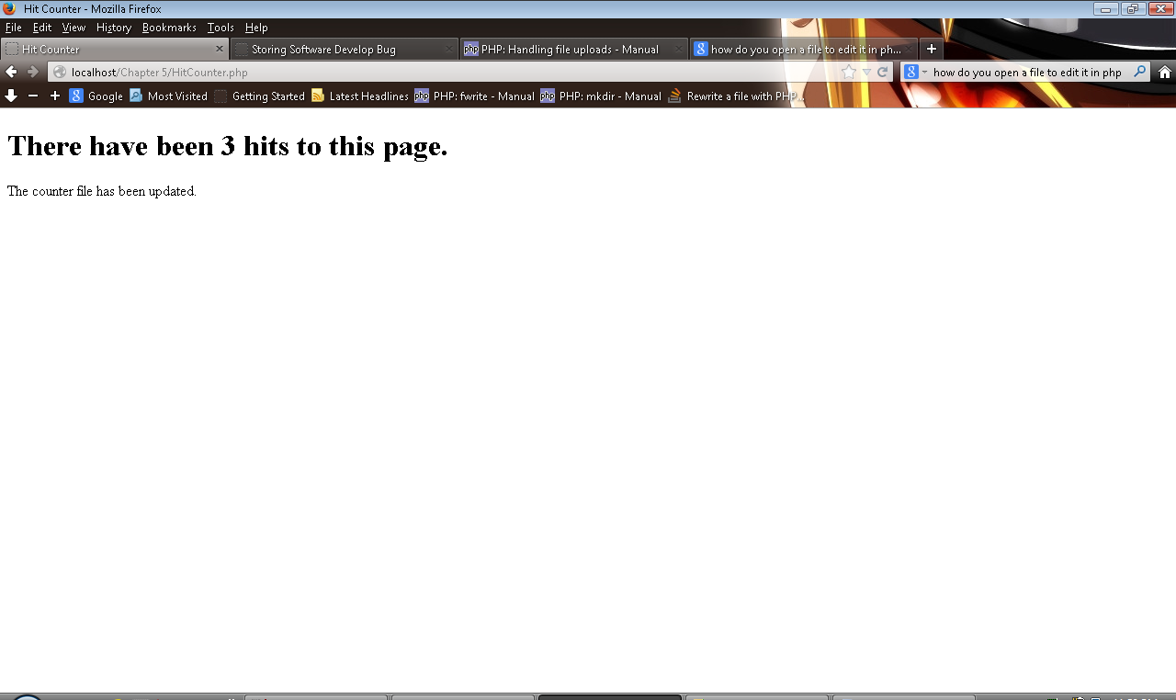

5-2

<!DOCTYPE html PUBLIC "-//W3C//DTD XHTML 1.0 Strict//EN"

"http://www.w3.org/TR/xhtml1/DTD/xhtml1-strict.dtd">

<html xmlns="http://www.w3.org/1999/xhtml">

<head>

<title>Guest Book</title>

<meta http-equiv="content-type" content="text/html; charset=iso-8859-1" />

</head>

<body>

<h2>Enter your name to sign our guest book</h2>

<form method="POST" action="SignGuestBook.php">

<p>First Name <input type="text" name="first_name" /></p>

<p>Last Name <input type="text" name="last_name" /></p>

<p><input type="submit" value="Submit" /></p>

</form>

<p><a href="ShowGuestBook.php">Show Guest Book</a></p>

<?php

?>

</body>

</html>

<!DOCTYPE html PUBLIC "-//W3C//DTD XHTML 1.0 Strict//EN"

"http://www.w3.org/TR/xhtml1/DTD/xhtml1-strict.dtd">

<html xmlns="http://www.w3.org/1999/xhtml">

<head>

<title>Sign Guest Book</title>

<meta http-equiv="content-type" content="text/html; charset=iso-8859-1" />

</head>

<body>

<?php

if(empty($_POST['first_name']) || empty($_POST['last_name']))

echo "<p>You must enter your first and last name. Click your browser's Back button

to return to the Guest Book.</p>\n";

else{

$FirstName = addslashes($_POST['first_name']);

$LastName = addslashes($_POST['last_name']);

$GuestBook = fopen("guestbook.txt", "ab");

if(is_writeable("guestbook.txt")){

if(fwrite($GuestBook, $LastName . ", " . $FirstName . "\n"))

echo "<p>Thank you for signing our guest book!</p>\n";

else

echo "<p>Cannot add your name to the guest book.</p>\n";

}

else

echo "<p>Cannot write to the file.</p>\n";

fclose($GuestBook);

}

?>

</body>

</html>

<!DOCTYPE html PUBLIC "-//W3C//DTD XHTML 1.0 Strict//EN"

"http://www.w3.org/TR/xhtml1/DTD/xhtml1-strict.dtd">

<html xmlns="http://www.w3.org/1999/xhtml">

<head>

<title>Show Guest Book</title>

<meta http-equiv="content-type" content="text/html; charset=iso-8859-1" />

</head>

<body>

<?php

echo "<h2>Guest Book</h2>";

echo "<hr />";

echo "<pre>\n";

readfile("guestbook.txt");

echo "</pre>\n";

echo "<hr />\n";

?>

</body>

</html>

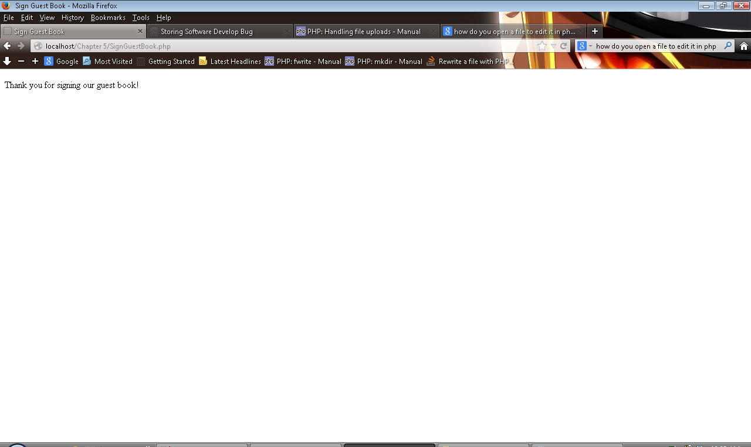

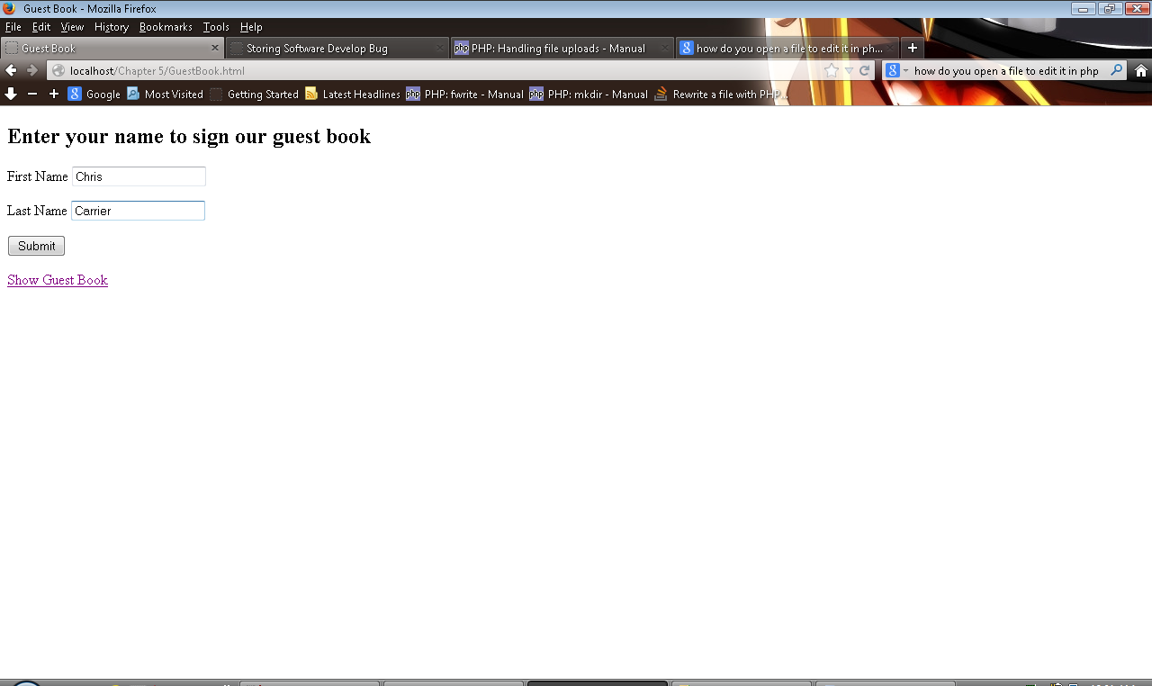

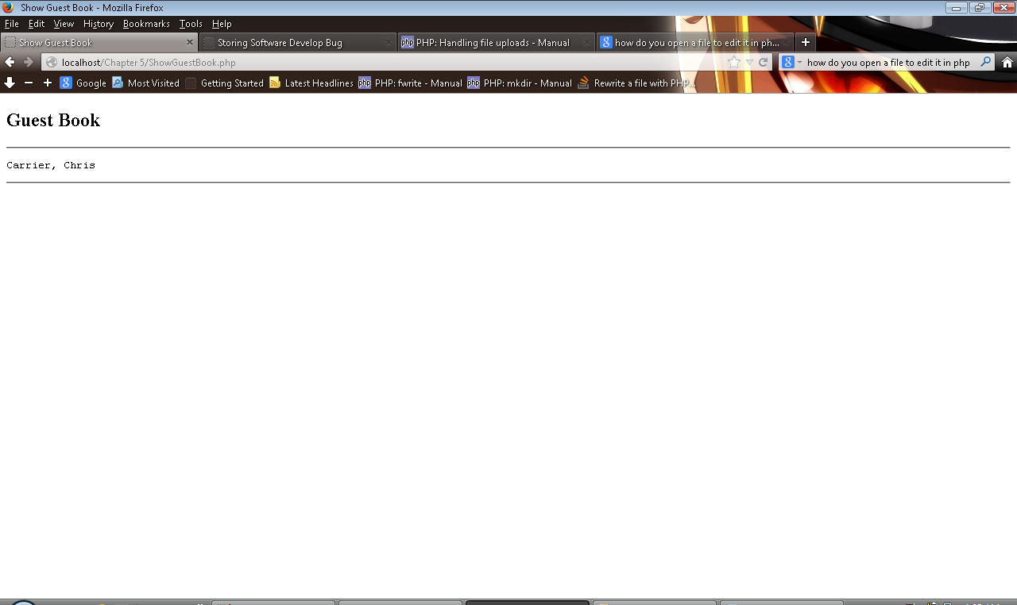

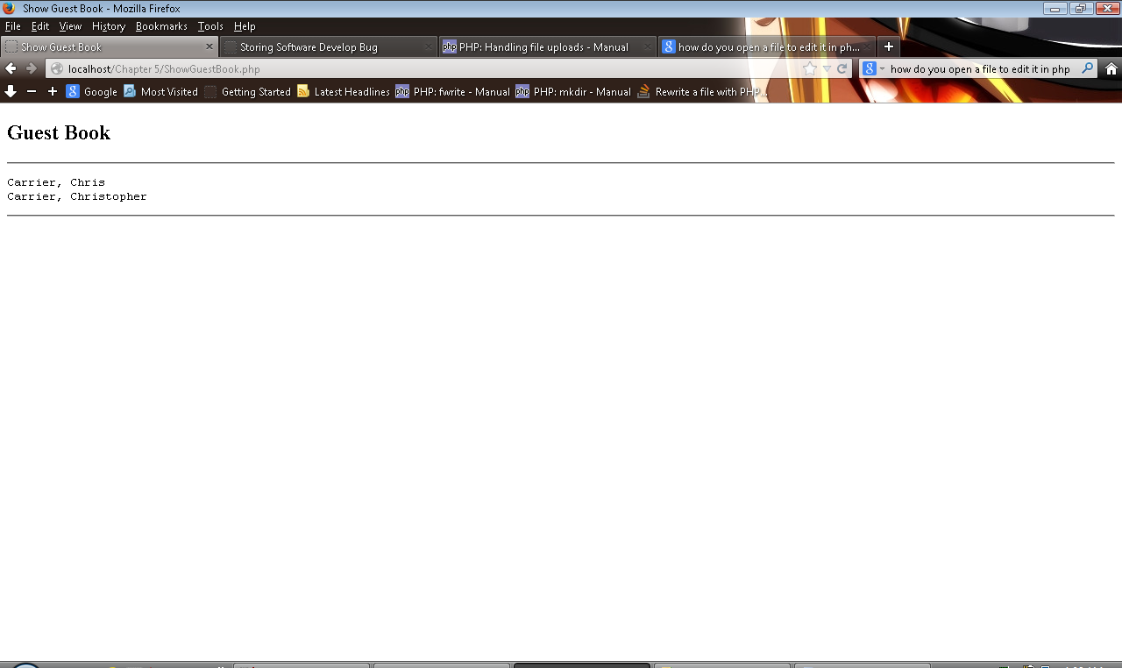

5-4 --- I had problems with this and kind of got lost. So im interested in result.

<!DOCTYPE html PUBLIC "-//W3C//DTD XHTML 1.0 Strict//EN"

"http://www.w3.org/TR/xhtml1/DTD/xhtml1-strict.dtd">

<html xmlns="http://www.w3.org/1999/xhtml">

<head>

<title>Storing Software Develop Bug</title>

<meta http-equiv="content-type" content="text/html; charset=iso-8859-1" />

</head>

<body>

<?php

$formfields = array('product', 'version', 'typehardware', 'operatingsystem', 'frequencyoccurrence',

'proposedsolution');

$output = "";

$failed = FALSE;

$Dir = "Files";

//Directory Check

/*if(is_dir($Dir) == $failed){

mkdir($Dir);

}

else{

$failed = TRUE;

}*/

//Field Check

foreach($formfields as $fields){

if(empty($_POST[$fields])){

echo "<p>You must enter every " . $fields . ". Click your browser's Back button

to return to the Bug Report.</p>\n";

$failed = TRUE;

}

else{

$_POST[$fields] = addslashes($_POST[$fields]);

$output = $output . "\n " . $_POST[$fields];

}

}

//Output

if(!$failed){

$NewBugReport = fopen("bugreport.txt", "w+");

if(is_writeable("bugreport.txt")){

if(fwrite($NewBugReport, $output . "\n ")){

//chmod("bugreport.txt", 0766);

echo "<p>Bug Report Successfully Entered!</p>\n";

echo "<hr />";

echo "<h2>Bug Report</h2>";

echo "<hr />";

echo "<pre>\n";

readfile("bugreport.txt");

echo "</pre>\n";

echo "<hr />\n";

}

else{

echo "<p>Couldn't Enter Bug Report!! >:( </p>\n";

}

}

else

echo "<p>Cannot write to the file.</p>\n";

fclose($NewBugReport);

}

//File Move

/*if(isset($_POST['submit'])){

if(isset($_FILES['new_file'])){

if(move_uploaded_file($_FILES['new_file']['tmp_name'], $Dir . "/" . $_FILES['new_file']['name']) == TRUE){

chmod($Dir . "/" . $_FILES['new_file']['name'], 0766);

echo "File \"" . htmlentities($_FILES['new_file']['name']) . "\" successfully uploaded. <br />\n";

}

else{

echo "There was an error uploading \"" . htmlentities($_FILES['new_file']['name']) . "\".<br />\n";

}

}

}*/

?>

</body>

</html>

<!DOCTYPE html PUBLIC "-//W3C//DTD XHTML 1.0 Strict//EN"

"http://www.w3.org/TR/xhtml1/DTD/xhtml1-strict.dtd">

<html xmlns="http://www.w3.org/1999/xhtml">

<head>

<title>New Bug Report</title>

<meta http-equiv="content-type" content="text/html; charset=iso-8859-1" />

</head>

<body>

<form action="storingsoftwarebug.php" method="post" enctype="multipart/form-data">

<table>

<tr>

<td>Product Name: </td>

<td><input type="text" name="product" required /><br /></td>

</tr>

<tr>

<td>Version: </td>

<td><input type="text" name="version" required /><br /></td>

</tr>

<tr>

<td>Type of Hardware: </td>

<td><input type="text" name="typehardware" required /><br /></td>

</tr>

<tr>

<td>Operating System: </td>

<td><input type="text" name="operatingsystem" required /><br /></td>

</tr>

<tr>

<td>Frequency of Occurrence: </td>

<td><input type="text" name="frequencyoccurrence" required /><br /></td>

</tr>

<tr>

<td>Proposed Solutions: </td>

<td><input type="text" name="proposedsolution" required /><br /></td>

</tr>

<tr>

<td><input type="reset" value="Clear Form" /></td>

<td><input type="submit" name="submit" value="Send Form" /></td>

</tr>

</table>

</form>

<?php

?>

</body>

</html>

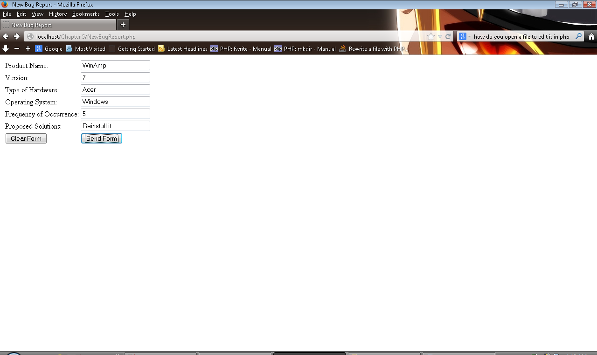

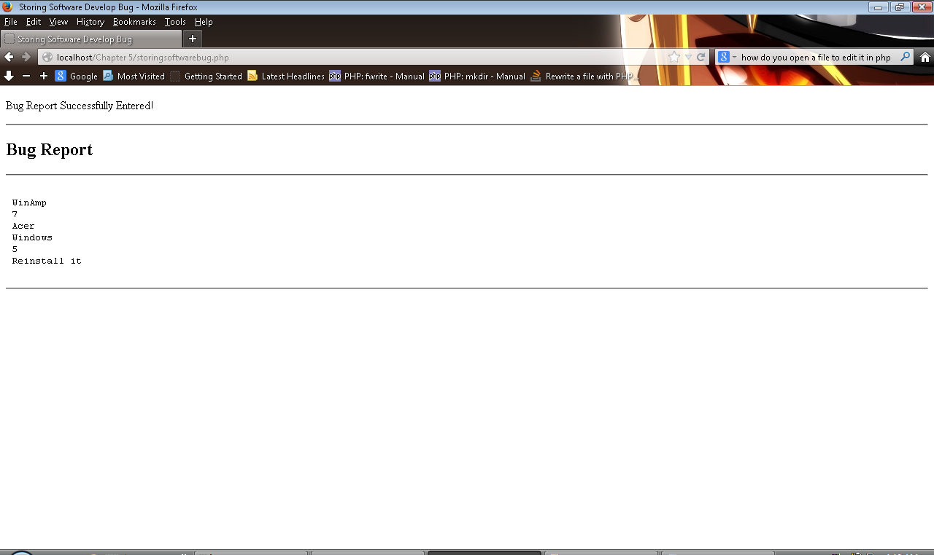

5-4 I realized to late how to do this. I’m also just realizing I missed a lot to output

<!DOCTYPE html PUBLIC "-//W3C//DTD XHTML 1.0 Strict//EN"

"http://www.w3.org/TR/xhtml1/DTD/xhtml1-strict.dtd">

<html xmlns="http://www.w3.org/1999/xhtml">

<head>

<title>Display Reunion Data</title>

<meta http-equiv="content-type" content="text/html; charset=iso-8859-1" />

</head>

<body>

<?php

$formfields = array('name', 'image_description', 'file_name');

$Dir = "Files";

$output = "";

$failed = FALSE;

/*//Directory Check

if(is_dir($Dir) == $failed){

mkdir($Dir);

}

else{

$failed = TRUE;

}*/

//Field Check

foreach($formfields as $fields){

if(empty($_POST[$fields])){

echo "<p>Please complete all parts of this form. This field was not filled out: " . $fields . ".

Click your browser's Back button to return to the High School Renuion Form page.</p>\n";

$failed = TRUE;

}

else{

$_POST[$fields] = addslashes($_POST[$fields]);

$output = $output . "\n " . $_POST[$fields];

}

}

/*//File Move

if(isset($_POST['upload'])){

if(isset($_FILES['file_name'])){

if(move_uploaded_file($_FILES['file_name']['tmp_name'], $Dir . "/" . $_FILES['file_name']['name']) == TRUE){

chmod($Dir . "/" . $_FILES['file_name']['name'], 0766);

echo "File \"" . htmlentities($_FILES['file_name']['name']) . "\" successfully uploaded. <br />\n";

}

else{

echo "There was an error uploading \"" . htmlentities($_FILES['file_name']['name']) . "\".<br />\n";

}

}

}*/

?>

</body>

</html>

l PUBLIC "-//W3C//DTD XHTML 1.0 Strict//EN"

"http://www.w3.org/TR/xhtml1/DTD/xhtml1-strict.dtd">

<html xmlns="http://www.w3.org/1999/xhtml">

<head>

<title>High School Reunion Form</title>

<meta http-equiv="content-type" content="text/html; charset=iso-8859-1" />

</head>

<body>

<form action="DisplayReunionData.php" method="POST" enctype="multipart/form-data">

<table>

<tr>

<td>Name: </td>

<td><input type="text" name="name" required /><br /></td>

</tr>

<tr>

<td>Image Description: </td>

<td><input type="text" name="image_description" size="100" required /><br /></td>

</tr>

<tr>

<td><hr width="600%" /></td>

</tr>

<tr>

<td><input type="hidden" name="MAX_FILE_SIZE" value "25000" /><br /></td>

</tr>

<tr>

<td>File Name: </td>

<td><input type="file" name="file_name" required />(25,000 byte limit)<br /></td>

</tr>

<tr>

<td><input type="reset" value="Clear Form" /></td>

<td><input type="submit" name="upload" value="Upload the File" /></td>

</tr>

</table>

</form>

<?php

?>

</body>

</html>

